



2019

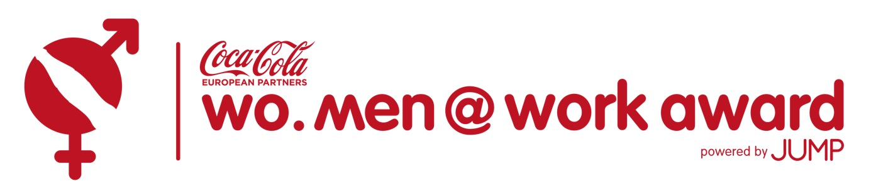

The corporate gender ambassador for gender equality



**How to become a JUMP Wo.Men@Work Award Partner?**

**Option 1: You choose to nominate your CEO (or C-level manager)**

Your application will provide you with visibility of your gender diversity actions throughout

our publications on the web site of the Award, in the JUMP newsletter and in the databases

of good practices of the Belgian Institute for Equality between Women and Men:

http://www.iefh-action.be/ and in the press.

Even if your candidate is not amongst the 3 nominees, one of your best practices may be

selected and put in the spotlight at the Ceremony of the Award and in the press.

**The assessment criteria are the following:**

- Facts and figures of gender balance in the last 3 years

- The personal commitment of the candidate

- The quality of the gender diversity action plan: innovation, implementation, sustainability,

results, etc.

**The candidature application** (Jump_Award_2019_technical_application.docx) **must be**

**received by November 24th 2018.** Application is completely free of charge.

The 3 nominees selected by the jury, will be interviewed and a video will be released on the

Award website and available on YouTube. You can use it for your own purpose.

A call to vote will be sent to the public.

The 3 nominees will meet the jury on Thursday 28nd February 2019 and promote their candidature.

The final result is calculated upon the base of 40% for the on-line voting and 60% for the

jury voting.

**Option 2: You choose to be part of the jury**

**If you feel your organisation is not ready yet to nominate your CEO, you can partner**

**nevertheless and benefit from visibility and gender equality knowledge. How?**

**Award partnership: 3.800€ early bird until 1st November 2018 or 4 500€ from November on**

* Your company can only be a member of the jury if your CEO is not nominated as a

candidate

* You get all the candidates’ applications and you take part in 2 jury meetings (**lunch time on** **20th December 2018** and **28th February 2019**)
* The list of the current members can be found here *(link to* [*http://www.womenatworkaward.be/jury*](http://www.womenatworkaward.be/jury)*)*
* As a partner, you get visibility with your logo in the press, in brochures, website and e-mailings (5 e-mailings to more than 100.000 contacts in Europe) *
* NEW! You receive a table for 10 participants to the Award Ceremony on the 26th of March 2019  
  (18:30 – 22:00 with walking diner)

**\*Advert Example**

**Order form: JUMP Award**

Surname: ______________________ First name: __________________________

Job title: ________________________ E-mail: _____________________________

Tel.: ___________________________ Mobile: _____________________________

VAT: _______________________________________

Invoice details (postal address)

__________________________________________________

Partnership Award = €3.800 ex. VAT (before1.11.2018)

€4.500 ex. VAT (After 1.11.2018)

**Administration cost** = € 150

**Total amount** = € ...................

**Total including VAT (if applicable)** = € ...................

I have read and accepted the general conditions available on jumpforum.eu/files/conditions.pdf. This

order is valid only after receipt and confirmation by email, fax or post.

**Date and signature:**

**Please mail the completed and signed document to info@jump.eu.com or fax to +32 (0)2 346 79 00. Thank you!**